Jacob Smith 6/22/2020 4:55 PM: This notebook will document he programming done for the Embedded Helper Arduino IDE extension.

I am receiving the error message “Can’t convert sketch into class, got hung up at”

The body and header files aren’t being created

Documentation needs to be written for the extension, probably with a user report form

Could add a dependency feature

Learn how to release code without source

Set up unit testing

Added error message showing up red

//sets text of current tab

editor.getCurrentTab().setText("AAA");

//print message to screen

editor.statusNotice("Now that feels better, doesn't it?");

I am trying to create library tabs without protected access, this may not be possible. I can’t add to the tabs directly because the list of tabs is returned as an umodifieable list 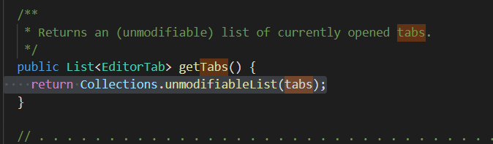

Results in unsupported operation exception

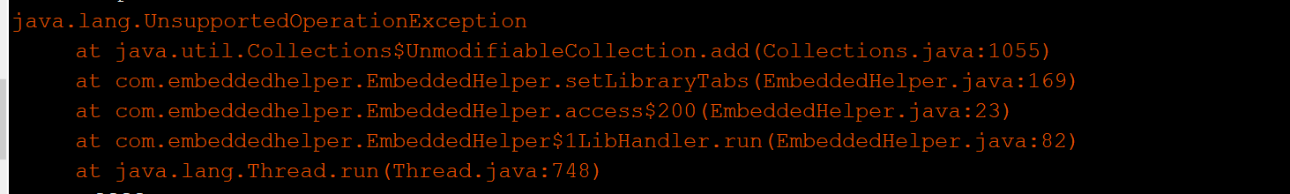

However, I can make tabs manually by creating new sketch files. Essentially, I’m trying to reverse engineer how the Arduino Ide creates new files so I can do it from the tool extension.

Update: I can create new files that show up together, but they don’t automatically refresh. I don’t think I can automatically refresh the tabs, and I also can’t quit and reopen the window to force a refresh because I don’t have access to the Base class.

// create and set text of all tabs

// the name of every tab starts with className, because tabs are alphabetized

// create body tabs

// get new name for folder

/*FileDialog fd = new FileDialog(editor, tr("Save sketch folder as..."), FileDialog.SAVE);

if (isReadOnly() || isUntitled()) {

// default to the sketchbook folder

fd.setDirectory(BaseNoGui.getSketchbookFolder().getAbsolutePath());

} else {

// default to the parent folder of where this was

// on macs a .getParentFile() method is required

fd.setDirectory(sketch.getFolder().getParentFile().getAbsolutePath());

}

String oldName = sketch.getName();

fd.setFile(oldName);

fd.setVisible(true);

String newParentDir = fd.getDirectory();

String newName = fd.getFile();

// user canceled selection

if (newName == null) return false;

newName = SketchController.checkName(newName);

File newFolder;

// User may want to overwrite a .ino

// check if the parent folder name ends with the sketch name

newFolder = new File(newParentDir, newName);

// check if the paths are identical

if (newFolder.equals(sketch.getFolder())) {

// just use "save" here instead, because the user will have received a

// message (from the operating system) about "do you want to replace?"

return save();

}

try {

sketch.saveAs(newFolder);

} catch (IOException e) {

}

///////////////////////////base approach to new file base.handleNew

File file = createNewUntitled();

if (file != null) {

handleOpen(file, true);

}

editor.updateTitle();

editor.createTabs();

//////////////////////////// base.CreateNewUntitled

File newbieDir = null;

String newbieName = null;

// In 0126, untitled sketches will begin in the temp folder,

// and then moved to a new location because Save will default to Save As.

File sketchbookDir = BaseNoGui.getSketchbookFolder();

File newbieParentDir = untitledFolder;

// Use a generic name like sketch_031008a, the date plus a char

int index = 0;

//SimpleDateFormat formatter = new SimpleDateFormat("yyMMdd");

//SimpleDateFormat formatter = new SimpleDateFormat("MMMdd");

//String purty = formatter.format(new Date()).toLowerCase();

Calendar cal = Calendar.getInstance();

int day = cal.get(Calendar.DAY_OF_MONTH); // 1..31

int month = cal.get(Calendar.MONTH); // 0..11

String purty = months[month] + PApplet.nf(day, 2);

do {

if (index == 26*26) {

// In 0166, avoid running past zz by sending people outdoors.

if (!breakTime) {

showWarning(tr("Time for a Break"),

tr("You've reached the limit for auto naming of new sketches\n" +

"for the day. How about going for a walk instead?"), null);

breakTime = true;

} else {

showWarning(tr("Sunshine"),

tr("No really, time for some fresh air for you."), null);

}

return null;

}

int multiples = index / 26;

if(multiples > 0){

newbieName = ((char) ('a' + (multiples-1))) + "" + ((char) ('a' + (index % 26))) + "";

}else{

newbieName = ((char) ('a' + index)) + "";

}

newbieName = "sketch_" + purty + newbieName;

newbieDir = new File(newbieParentDir, newbieName);

index++;

// Make sure it's not in the temp folder *and* it's not in the sketchbook

} while (newbieDir.exists() || new File(sketchbookDir, newbieName).exists());

// Make the directory for the new sketch

newbieDir.mkdirs();

// Make an empty pde file

File newbieFile = new File(newbieDir, newbieName + ".ino");

if (!newbieFile.createNewFile()) {

throw new IOException();

}

FileUtils.copyFile(new File(getContentFile("examples"), "01.Basics" + File.separator + "BareMinimum" + File.separator + "BareMinimum.ino"), newbieFile);

return newbieFile;*/

BUG: Found error with morse example file, pinMode command should be in begin

STATUS: Now the extension creates the body and header files, and I print a message t oclose the window and reopen because I can’t refresh automatically. Also, the extra printout error is solved.

FEATURE: The new files could be created in libraries folder, or the user could set that during save as.

FEATURE: the depends feature could be added

BUG: The automatically generated morse library does not compile

<https://superuser.com/questions/489180/remove-r-from-echoing-out-in-bash-script>

TODO

Replace lnikedlist, linkedlistnode, and miniscanner with Java equivalents

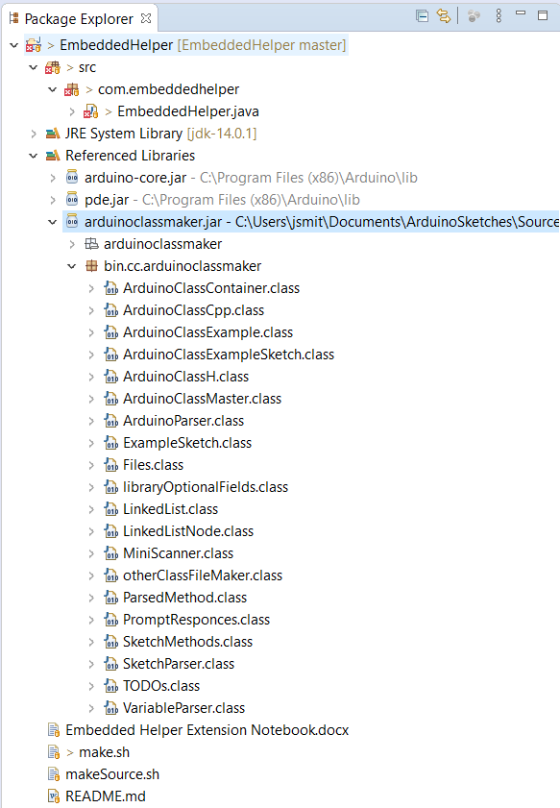

<https://stackoverflow.com/questions/4322893/eclipse-error-the-import-xxx-cannot-be-resolved>

FIXED: removed dummy classes from arduinoclassmaker repository

FEAUTRE: add obfuscation

BUG: EmbededHelper extension must include source code

No class def found error <https://stackoverflow.com/questions/34413/why-am-i-getting-a-noclassdeffounderror-in-java>

{<https://superuser.com/questions/489180/remove-r-from-echoing-out-in-bash-script>

TODO

Replace lnikedlist, linkedlistnode, and miniscanner with Java equivalents

Installed hacmrest and junit, got error and these two links fixed it

<https://stackoverflow.com/questions/55571046/eclipse-is-confused-by-imports-accessible-from-more-than-one-module>

<https://docs.infor.com/help_m3_coreit_13.4/index.jsp?topic=%2Fcom.lawson.help.administration%2Fcom.lawson.help.makag-w_10.1.2%2FL157071229479555.html>

BUG: LinkedList LinkedListNode and MiniScanner should be replaced with Java equivalents

}

Links

<https://behosted.org/best-jsp-web-hosting/>

<https://www.hostgator.com/help/article/tomcat-java>

<https://www.ntu.edu.sg/home/ehchua/programming/java/JavaServletExamples.html>

Java Web Text Boxes Links [1](https://www.tutorialspoint.com/jsp/jsp_form_processing.htm) [2](https://stackoverflow.com/questions/44347054/how-to-get-the-output-of-a-jsp-file-in-an-html-text-field) [3](http://www.java2s.com/Code/Java/JSP/FormTextFieldDemo.htm)